# *TUGAS*

## *SOAL*

1. Berdasarkan gambar di bawah, buatlah tabel-tabel pada ERD menggunakan perintah SQL DDL.
2. Jawaban perintahnya, masukan ke dalam kolom jawaban di bawah!
3. Disimpan dan disubmit ke kantong tugas dalam format **.docx** atau **.pdf**

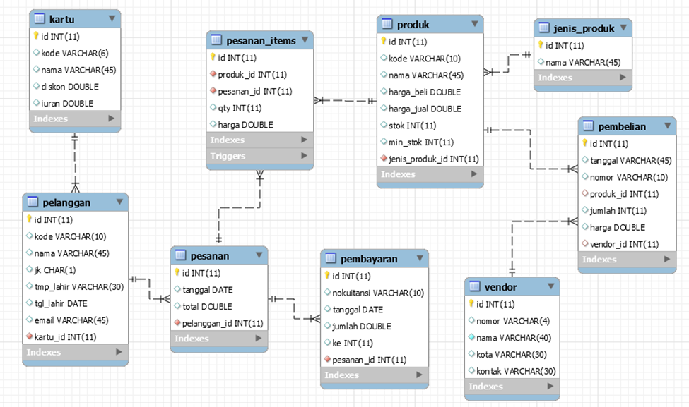

***JAWABAN***

*CREATE DATABASE tugas_19;*

*CREATE TABLE kartu (*

*id INT auto_increment primary key,*

*kode VARCHAR(4) unique,*

*nama VARCHAR(30) NOT NULL,*

*diskon DOUBLE DEFAULT 0,*

*iuran DOUBLE DEFAULT 0*

*);*

*CREATE TABLE pelanggan(*

*id INT auto_increment primary key,*

*kode VARCHAR(10) unique,*

*nama VARCHAR(45) NOT NULL,*

*jk CHAR(1) NOT NULL,*

*tmp_lahir VARCHAR(30),*

*tgl_lahir DATE,*

*email VARCHAR(45),*

*kartu_id INT,*

*FOREIGN KEY (kartu_id) REFERENCES kartu(id));*

*CREATE TABLE pesanan(*

*id INT auto_increment primary key,*

*tanggal DATE,*

*total DOUBLE DEFAULT 0,*

*pelanggan_id INT,*

*FOREIGN KEY (pelanggan_id) REFERENCES pelanggan(id)*

*);*

*CREATE TABLE pembayaran(*

*id INT auto_increment primary key,*

*nokuitansi VARCHAR(10),*

*tanggal DATE,*

*jumlah DOUBLE DEFAULT 0,*

*ke INT,*

*pesanan_id INT,*

*FOREIGN KEY (pesanan_id) REFERENCES pesanan(id)*

*);*

*CREATE TABLE jenis_produk(*

*id INT auto_increment primary key,*

*nama VARCHAR(45) NOT NULL*

*);*

*CREATE TABLE produk(*

*id INT auto_increment primary key,*

*kode VARCHAR(10) unique,*

*nama VARCHAR(45) NOT NULL,*

*harga_beli DOUBLE DEFAULT 0,*

*harga_jual DOUBLE DEFAULT 0,*

*stok INT,*

*min_stok INT,*

*jenis_produk_id INT,*

*FOREIGN KEY (jenis_produk_id) REFERENCES jenis_produk(id)*

*);*

*CREATE TABLE vendor(*

*id INT auto_increment primary key,*

*nomor VARCHAR(4) unique,*

*nama VARCHAR(40) NOT NULL,*

*kota VARCHAR(30),*

*kontak VARCHAR(30) NOT NULL*

*);*

*CREATE TABLE pembelian(*

*id INT auto_increment primary key,*

*tanggal VARCHAR(45) NOT NULL,*

*nomor VARCHAR(10) unique,*

*jumlah INT,*

*harga DOUBLE DEFAULT 0,*

*produk_id INT,*

*vendor_id INT,*

*FOREIGN KEY (produk_id) REFERENCES produk(id),*

*FOREIGN KEY (vendor_id) REFERENCES vendor(id)*

*);*

*CREATE TABLE pesanan_items(*

*id INT auto_increment primary key,*

*qty INT,*

*harga DOUBLE DEFAULT 0,*

*produk_id INT,*

*pesanan_id INT,*

*FOREIGN KEY (produk_id) REFERENCES produk(id),*

*FOREIGN KEY (pesanan_id) REFERENCES pesanan(id)*

*);*

*INSERT INTO jenis_produk VALUES*

*(DEFAULT, 'Skin Care'),*

*(DEFAULT, 'Hair Care'),*

*(DEFAULT, 'Body Care');*

*(DEFAULT, 'Fragrance');*

*(DEFAULT, 'Make Up');*

*INSERT INTO produk VALUES*

*(DEFAULT, 'SC00001', 'Face Cleanser', '189000', '364000', '600', '10', 1),*

*(DEFAULT, 'SC00002', 'Face Toner', '223000', '442000', '750', '10', 1),*

*(DEFAULT, 'SC00003', 'Face Serum', '244000', '661000','400', '10', 1),*

*(DEFAULT, 'HC00001', 'Hair Shampoo', '63122', '85300', '900', '10', 2),*

*(DEFAULT, 'HC00002', 'Hair Mask', '100408', '130400', '890', '10', 2),*

*(DEFAULT, 'HC00003', 'Hair Tonic','59085', '90900', '560', '10', 2),*

*(DEFAULT, 'BC00001', 'Body Wash', '144000', '170000','405', '10', 3),*

*(DEFAULT, 'BC00002', 'Body Scrub', '106000', '125000', '450', '10', 3),*

*(DEFAULT, 'BC00003', 'Body Lotion', '110000', '135000', '560', '10', 3),*

*(DEFAULT, 'FG00001', 'Floral Perfume', '124000', '159000', '332', '10', 4),*

*(DEFAULT, 'FG00002', 'Fruity Perfume', '110000', '145000', '443', '10', 4),*

*(DEFAULT, 'FG00003', 'Candy Perfume', '130000', '155000', '554', '10', 4),*

*(DEFAULT, 'MU00001', 'Cushion', '267000', '387000', '770', '10', 5),*

*(DEFAULT, 'MU00002', 'Liquid Blush On', '90000', '129000', '429', '10', 5),*

*(DEFAULT, 'MU00003', 'Mascara', '79000', '67000', '1029', '10', 5);*

*INSERT INTO kartu VALUES*

*(DEFAULT, 'C001', 'Basic Card', '2', '10000'),*

*(DEFAULT, 'C002', 'Silver Card', '5', '30000'),*

*(DEFAULT, 'C003', 'Gold Card', '10', '50000'),*

*(DEFAULT, 'C004', 'Platinum Card', '15', '70000'),*

*(DEFAULT, 'C005', 'VIP Card', '20', '100000');*

*INSERT INTO pelanggan VALUES*

*(DEFAULT, 'CUST001', 'Ethan James Anderson', '', '', NULL, '', '1'),*

*(DEFAULT, 'CUST002', 'Mason Alexander Lee', '', 'New York', '1997-12-08', 'masonlee@gmail.com', '2'),*

*(DEFAULT, 'CUST003', 'Emma Grace Miller', 'P', 'Bangkok', NULL, 'emma@gmail.com', '3'),*

*(DEFAULT, 'CUST004', 'Sophia Elizabeth Smith', 'P', 'London', '1989-01-01', 'sophia@gmail.com', '4'),*

*(DEFAULT, 'CUST005', 'Taylor Swift', 'P', 'Cambodia', '1989-02-22', 'taylorswift@gmail.com', '5');*

*INSERT INTO vendor VALUES*

*('V001', 'SkINTific', 'Jakarta', '08123456789'),*

*('V002', 'Base', 'Bandung', '08223456789'),*

*('V003', 'Focallure', 'Surabaya', '08323456789'),*

*('V004', 'Wardah', 'Medan', '08423456789'),*

*('V005', 'Emina', 'Makassar', '08523456789');*

*INSERT INTO pembelian VALUES*

*(DEFAULT, '2024-12-01', 'B001', '10', '7000000', 1, 1),*

*(DEFAULT, '2024-12-02', 'B002', '20', '2000000', 2, 2),*

*(DEFAULT, '2024-12-03', 'B003', '30', '1500000', 3, 3),*

*(DEFAULT, '2024-12-04', 'B004', '15', '4500000', 4, 4),*

*(DEFAULT, '2024-12-05', 'B005', '25', '1750000', 5, 5);*

*INSERT INTO pesanan VALUES*

*(DEFAULT, '2024-12-01', 100000, 16),*

*(DEFAULT, '2024-12-02', 200000, 17),*

*(DEFAULT, '2024-12-03', 150000, 18),*

*(DEFAULT, '2024-12-04', 250000, 19),*

*(DEFAULT, '2024-12-05', 300000, 20);*

*INSERT INTO pembayaran VALUES*

*(DEFAULT, 'K001-2024', '2024-12-01', 100000, 1, 6),*

*(DEFAULT, 'K002-2024', '2024-12-02', 200000, 1, 7),*

*(DEFAULT, 'K003-2024', '2024-12-03', 150000, 2, 8),*

*(DEFAULT, 'K004-2024', '2024-12-04', 250000, 2, 9),*

*(DEFAULT, 'K005-2024', '2024-12-05', 300000, 3, 10);*

*INSERT INTO pesanan_items VALUES*

*(DEFAULT, 25, '7000000', 1, 6),*

*(DEFAULT, 38, '100000', 2, 7),*

*(DEFAULT, 12, '50000', 3, 8),*

*(DEFAULT, 14, '300000', 4, 9),*

*(DEFAULT, 53, '70000', 5, 10);*

